|  |  |  |  |  |  |  |
| --- | --- | --- | --- | --- | --- | --- |
| **Document History** | | | | | | |
| **Document Name** | **Version** | **Status** | **Date** | **Viewable** | **Editable** | **Response** |
| Promotion Provider_Project Plan_0.1 | Promotion Provider_Project Plan_0.1  **Added**   * Chapter 1 | Introduction * Chapter 2 | Software Process * Chapter 3 | Management Procedure * Chapter 4 | Quality Planning | Draft | 10-06-2015 | TS, NC, PS | TS, NC | NC |
| Promotion Provider_Project Plan_0.2 | Promotion Provider_Project Plan_0.2  **Added**   * Chapter 5 | Schedule and Milestones * Chapter 6 | Software Configuration * Chapter 7 | Repository | Draft | 10-07-2015 | TS, NC, PS | TS, NC | TS |
| Promotion Provider_Project Plan_1.0 | Promotion Provider_Project Plan_1.0  **Updated**   * Chapter 5 | Schedule and Milestones | Approved | 29-07-2015 | TS, NC, PS | TS, NC | TS |
| Promotion Provider_Project Plan_1.1 | Promotion Provider_Project Plan_1.1  **Updated**   * Features | Approved | 28-08-2015 | TS, NC, PS | TS, NC | TS |

Document Designed by

Tanawat Sitthitan  
Nattakit Chaiwongsri  
July 27, 2015   
  
Document Approved by

_______________  
Mr. Phudinan Singkhamfu

July 29, 2015

Content

List of Figure 4

List of Table 5

Chapter 1 | Introduction 6

1.1 Project overview 6

1.1.1 Identification 6

1.1.2 Scope 6

1.1.3 Document Overview 6

1.2 Work Product to be developed 6

1.2.1 Deliverables 6

1.2.2 Non-Deliverables 8

1.3. Acronyms and Definition 8

1.3.1 Key Definition configuration 8

1.3.2 Key Acronyms and Abbreviation 10

1.4 Identification of Project Risks 10

1.5 Estimated Duration of task 11

1.6 Project Constraints 11

1.6.1 Resource constraint 11

1.6.2 Environment constraint 11

Chapter 2 | Software Process 12

2.1 Monitoring and Controlling Mechanisms 12

2.1.1 Software Development Model 12

fea2.1.2 Status Report 13

2.1.3 Burn down chart 14

2.2 Change management 14

2.3 Development Tools 14

2.4 Software Resource 14

2.4 Hardware and Material Resource 15

Chapter 3 | Management Procedures 16

3.1 Project Team Structure 16

3.2 Monitoring and Controlling Mechanisms 16

Chapter 4 | Quality Planning 17

4.1 Reviews/Responsibility 17

4.2 Testing 17

4.3 Software Development Standard 17

4.3.1 Project Management (PM) process 17

4.3.2 Software Implementation (SI) process 19

Chapter 5| Schedule and Milestones 21

Chapter 6 | Software Configuration Management 25

6.1 Filename Format 25

6.2 Change Management 25

6.3 Software Configuration Item Table 26

Chapter 7 | Repository 27

## List of Figure

|  |  |
| --- | --- |
| Figure 2.1: Software Development Model…….……………………………………………………………………………. | 12 |
| Figure 2.2: Promotion Provider Schedule and Milestone ……………………………………………………………. | 21 |
| Figure 2.3: Proposal Milestone …………………………………………………………………………………………………… | 21 |
| Figure 2.4: Progress #1 Milestone …..…………………………………………………………………………………………. | 22 |
| Figure 2.5: Progress #2 Milestone ………………………………………………………………………………………………. | 22 |
| Figure 2.6: SE Show Pro Milestone ……………………………………………………………………………………………… | 23 |
| Figure 2.7: Final Progress Milestone……………………………………………………………………………………………. | 23 |
| Figure 2.8: Repository ……………….……………………………………………………………………………………………….. | 27 |

## List of Table

|  |  |
| --- | --- |
| Table 2.1: Deliverable…………………………………………………………………………………………………………………. | 8 |
| Table 2.2: Non - Deliverable………………………………………………………………………………………………………… | 8 |
| Table 2.3: Identification of Project Risks……………………………………………………………………………………… | 11 |
| Table 2.4: Estimated Duration of Task…………………………………………………………………………………………. | 11 |
| Table 2.5: Status Report……………………………………………………………………………………………………………… | 14 |
| Table 2.6: Project Team Structure………………………………………………………………………………………………. | 16 |
| Table 2.7: Monitoring and Controlling Mechanisms……………………………………………………………………. | 16 |
| Table 2.8: Reviews/Responsibility……………………………………………………………………………………………….. | 17 |
| Table 2.9: Software Configuration Item ……………………………………………………………………………………… | 26 |

# Chapter 1 | Introduction

## 1.1 Project overview

### 1.1.1 Identification

***Project name*: Promotion Provider**

Project plan is the document for developed planning for project, scheduling for manage time in each task that can make project keep on track, risk management and quality plan to make project getting high quality and avoid failure.

### 1.1.2 Scope

### We will establish an iPhone application, database, and server that use PHP to develop. The project will focus exclusively on the providing promotion and notification when a user gets closer than 20 meters. The user can also get direction from the current location to the restaurant or hotel destination, and they can also turn off the notification.

### 1.1.3 Document Overview

The purpose of this project Software Development Plan (SDP) documentation is to guide the project management during the development of the promotion provider project.

## 1.2 Work Product to be developed

### 1.2.1 Deliverables

|  |  |  |  |  |
| --- | --- | --- | --- | --- |
| **No.** | **Deliverables/Release** | **Media** | **No. of Copies** | **Date** |
| 1. | Project Proposal | Document | 1 | 10/06/2015 |
| 2. | **The progress report #1**  Documentation   * Project Plan * Software Requirement Specification (SRS) * Software Design Documentation (SDD) * Unit test   Software System   * User Interface Design * Feature Implementation * Feature #1 Managing shop owner: System provide managing function (add, update, delete) * Feature #2 Managing promotion: System provide managing function (add, edit and delete) * Feature #3 Changing password: All user type can change their password | Document  Software | 3 | 29/07/2015 |
| 3. | **The progress report #2**  Documentation   * Software Test Plan Documentation * System test   Software System   * Feature Implementation * Feature #4 Show promotion information: System provide the promotion information * Feature #5 Notification: System will notify user application when they get closer than 20 meters   + - * Feature #6 Turn off notification: User application can turn off notification | Document  Software | 3 | 23/09/2015 |
| 4. | **SE Show pro**  Documentation   * Unit test * System test * Poster A1 for presentation   Software System  - 30 seconds Introduction Clips   * Feature Implementation   + - * Feature #7 Searching: User application can search by place’s name       * Feature #8 Nearby: User application can see the promotion place in setting range       * Feature #9 Single sign on: User application can sign in to system by using Facebook’s account       * Feature #10 Sharing promotion: User application can share any promotions to Facebook | Document  Software | 3  3 | 18/11/2015 |
| 5. | **Final Progress**  Documentation   * The Full ISO 29110 Document   Software System   * 5 minutes Demo Program Clip | Document  Software | 3 | 28/12/2015 |

Table 2.1: Deliverable

### 1.2.2 Non-Deliverables

|  |  |  |
| --- | --- | --- |
| **No.** | **Work Product** | **Media** |
| 1 | Proposal Presentation | Power Point |
| 2 | The Progress Report #1 | Power Point |
| 3 | The Progress Report #2 | Power Point |
| 4 | The Final Progress Report | Power Point |

Table 2.2: Non - Deliverable

## 1.3. Acronyms and Definition

### 1.3.1 Key Definition configuration

|  |  |
| --- | --- |
| management | “A discipline applying technical and administrative direction and surveillance to: identify and document the functional and physical characteristics of configuration item, control change to those characteristics, record and report change processing implementation status, and verify compliance with specified requirements.” [IEEE90] |
| design | “The period of time in the software life cycle during which the design for architecture, software components, interfaces, and data are created, documented, and verified to satisfy requirements. ” [IEEE90] |
| implementation | “The period of time in the software life cycle during which a software product is created from documentation and debugged.” [IEEE90] |
| management | Designated corporate representative. |
| plan | “A detailed scheme, program, or method worked out beforehand for the accomplishment of an objective.” [IEEE90]  Defined set of procedures and the required resources to implement a policy. |
| process | “A sequence of steps performed for given purpose.” [IEEE90] |
| program | Organization unit. |
| quality assurance | “(1) A planed and systematic pattern of all actions necessary to provide adequate confidence that an item or product conforms to established technical requirement.” [IEEE90]  “(2) A set of activities designed to evaluate the process by which produces are developed or manufactured.” [IEEE90] |
| requirement | “(1) A condition or capability needed by a user to solve a problem or achieve an objective.” [IEEE90]  “(2) A condition or capability that must be met or possessed by a system or system component to satisfy a contract, standard, specification, or other formally imposed document.” [IEEE90] |
| requirements | “The period of time in the software life cycle during which the requirements for a software product are define and documented.” [IEEE90] |
| software | “Computer programs, procedures, and associated documentation and data pertaining to the operation of the computer system.” [IEEE90] |
| software engineering | “The application of a systematic, disciplined, quantifiable approach to the development, operation, and maintenance of software; that is, the application of engineering to software.” [IEEE90] |
| software quality assurance | See “quality assurance” |
| specification | “A document that specifies, in a complete, verifiable manner, the requirement, design, behavior, or other characteristics for determining whether these provisions have been satisfied.” [IEEE90] |
| validation | “The process of evaluating a system or component during or at the end of the development process to determine whether it satisfies specified requirement. ” [IEEE90] |
| verification | “(1) The process of evaluating a system or component to determine whether the products of given development activity that satisfy the conditions imposed at the start of that activity.”  “(2) Formal proof of program correctness.” [IEEE90] |
| work product | Any tangible item that results from a project function, activity, or task. Examples of work products include customer requirement s, project plan, design documents, source and object code, user‟s manuals. |

### 1.3.2 Key Acronyms and Abbreviation

|  |  |
| --- | --- |
| AD | Activity Diagram |
| SDD | Software Design Document |
| SPMP | Software Project Management Plan |
| SRS | Software Requirement Specification |
| UC | Use case |
| UI | User Interface |

## 1.4 Identification of Project Risks

|  |  |  |
| --- | --- | --- |
| **No.** | **Risk Statement** | **Risk Solution** |
| 1 | System Requirement May be change. | * Meeting and discuss and do a priority of changed requirement * Design system with changed requirements and related with the other requirements. |
| 2 | Team member maybe get accident and can’t develop the project. | * Assign a work to left team member who doesn’t get accident. |
| 3 | Computer lost or broken | * Back up project every time. |
| 4 | Work products are not submitted on time. | * Establish the project plan. * Develop project follow the project plan. |

Table 2.3: Identification of Project Risks

## 1.5 Estimated Duration of task

|  |  |  |
| --- | --- | --- |
| **No.** | **Task** | **Estimated Duration**  **(Days)** |
| 1 | - Proposal | 30 |
| 2 | - Software requirement and Software design | 30 |
| 3 | - Server (Web) | 30 |
| 4 | - Application (Mobile) | 40 |

Table 2.4:Estimated Duration of Task

## 1.6 Project Constraints

### 1.6.1 Resource constraint

* + Software developing must follow by ISO29110 Standard.
  + There are only two people for Promotion Provider project development.

### Environment constraint

* Objective –X-code tool and iPhone technology are new.
* Code igniter framework from develop web application are new framework.

# Chapter 2 | Software Process

## 2.1 Monitoring and Controlling Mechanisms

### 2.1.1 Software Development Model

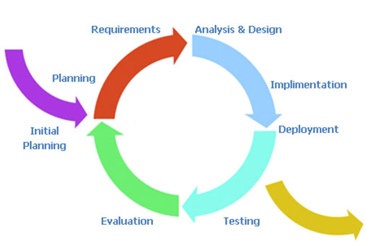

Figure 2.1 Software Development Model

**Iterative model** is a one of Software Development Model which evolves from waterfall model. By change process flows from step to step into iterative step. When the process flows into iterative, the process will start from the first step then go to the next step till the last. After that, the process will back to the first step and start again. The iteration will be repeating until all processes planned are complete then out from the loop and go to next main phase. The advantages of this model are support dividing and flexible. It can divide the system into subsystem or feature and then iterative create each feature. With this, a chance of project failure will be reduced because it can detect a problem early before integrating into the system.

**Proposal phase:** This phase is about creating a proposal for Junior fighting. The proposal contains about project introduction, technologies and tool involved, quality standard and project plan.

**Document plan phase:** This phase is a document for planning and designs the overall system from requirement given by the user. These documents are Project Management Plan, Software Requirement Specification and Software Design Document.

**Iterative all features:** This phase is about separate system into many features and then iterative create all feature from the first feature till the final feature. For this phase, it will be divided into 4 phases. There are;

* **Plan:** Planning the method for creating and test each feature.
* **Implement:** Implement and coding each feature.
* **Test:** Test and debug each feature.
* **Review:** Review and maintain each feature to meet the feature plan.

**System test phase:** This phase will integrate all features together into one system and then create test document from system testing.

**Deploy phase:** This phase is about deploy the whole system to server and use as a regular mobile application.

### fea2.1.2 Status Report

|  |  |  |  |
| --- | --- | --- | --- |
| **No.** | **Progress report** | **Software Item** | **Date** |
| 1. | Project Proposal | Proposal | 10/06/2015 |
| 2. | The progress report #1 | Project Plan & Quality Plan  Software Requirement specification 1.0  Software Design Document 1.0  Software Source code 1.0  Test Plan 1.0  Test Record 1.0  Traceability record 1.0 | 29/07/2015 |
| 3. | The progress report #2 | Software Requirement specification 2.0  Software Design Document 2.0  Software Source code 2.0  Test Plan 2.0  Test Record 2.0  Traceability record 2.0 | 23/09/2015 |
| 4. | SE Show pro | Unit test  System test  Poster A1 for presentation  30 seconds Introduction Clip | 18/11/2015 |
| 5. | Final Progress | Software Requirement specification (complete)  Software Design Document (complete)  Software Source code (complete)  Test Plan (complete)  Test Record (complete)  Traceability record (complete) | 28/12/2015 |

Table 2.5: Status Report

### 2.1.3 Burn down chart

* Project status report

## 2.2 Change management

Change control procedure

1. Analyze the reason for the change.
2. Send change form to project advisor.
   1. If accept: make a change in project from change request form.
   2. If reject: Continue in the project and find the way to solve a problem.
3. Analyze the result from changing and modify the document or system to match with change.

## 2.3 Development Tools

* PhpStrom Version 7.1
* XAMPP Version 1.8.2
* Google chrome
* MySQL Workbence

## 2.4 Software Resource

* Promotion provider is developed on iOS mobile platform
  + Firmware
    - iOS 7

## 2.4 Hardware and Material Resource

* Computer
  + MacBook Pro (15-inch, Late 2011)
  + Processor: 2.2 GHz Intel Core i7
  + Memory: 8 GB 1600 MHz DDR3
  + Graphics: Intel HD Graphics 3000 512 MB
  + Operating System (OS): OS X Yosemite version 10.10.4
* Smartphone
  + iPhone 4
  + iPhone 4s
  + iPhone 5s
  + iPod touch gen 5
* Internet
  + Internet access speeds more than 250 Kbps

# Chapter 3 | Management Procedures

## 3.1 Project Team Structure

|  |  |  |  |
| --- | --- | --- | --- |
| **No.** | **Participants** | **Role** | **Responsibility** |
| 1 | Tanawat Sitthitan | Developer, Tester | * Develop software * Test software * Test Unit test * Review Document and software Manage change |
| 2 | Nattakit Chaiwongsri | Tester, Reviewer | * Create Documentation * Proposal * Project plan * Quality Plan * SRS * SDD * Test Plan * Test Record * Traceability Record * Review Document and software |
| 3 | Mr.Phudinan Singkhamfu | Advisor, Reviewer | * Review document * Approved document * Approved change request |

Table 2.6: Project Team Structure

## 3.2 Monitoring and Controlling Mechanisms

|  |  |  |
| --- | --- | --- |
| **No.** | **Participants** | **Responsibility** |
| 1 | Tanawat Sitthitan | Developer, SA |
| 2 | Nattakit Chaiwongsri | Document, SA |
| 3 | Mr.Phudinan Singkhamfu | Advisor, SA |

Table 2.7: Monitoring and Controlling Mechanisms

# Chapter 4 | Quality Planning

## 4.1 Reviews/Responsibility

|  |  |  |  |
| --- | --- | --- | --- |
| **Stage Exit Review** | | | |
| **No.** | **Stage** | **Review Item** | **Responsibility** |
| 1 | Requirement | - SRS | Tanawat, Nattakit |
| 2 | Design | - Use case diagram  - Activity diagram  - Sequence diagram | Tanawat, Nattakit |
| 3 | Implementation | - Code | Tanawat, Nattakit |
| 4 | Verification | - Unit test  - Test case  - Test plan | Tanawat, Nattakit |
| 5 | Maintenance | - Maintenance report | Tanawat, Nattakit |

Table 2.8: Reviews/Responsibility

## 4.2 Testing

**Refer**: Test Plan Documentation

## 4.3 Software Development Standard

#### ISO 29110 for Very Small Entity (VSE)

ISO 29110 is the Software Life Cycle Profiles and Guidelines for Very Small Entities (VSEs) standards and technical reports are targeted at Very Small Entities (VSEs). A Very Small Entity (VSE) is an enterprise, organization, department or project having up to 25 people. ISO 29110 concerns on project management process and software implementation process.

### 4.3.1 Project Management (PM) process

* **Purpose**

The purpose of the Project Management process is to establish and carry out in a systematic way the tasks of the software implementation project, which allows complying with the project’s objectives in the expected quality, time and costs.

* **Objectives**
* **PM.O1.** The *Project Plan* for the execution of the project is developed according to the *Statement of Work* and validated with the Customer. The tasks and resources necessary to complete the work are sized and estimated
  + - **PM.O1. Tasks in this project:**

1. Create the Project Plan related with the Project Proposal.

* **PM.O2.** Progress of the project is monitored against the *Project Plan* and recorded in the *Progress Status Record.* Corrections to remediate problems and deviations from the plan are taken when project targets are not achieved. . Appropriate treatment is taken to correct or avoid the impact of risk. Closure of the project is performed to get the Customer acceptance documented in the *Acceptance Record*
  + - **PM.O2. Tasks in this project:**

1. Record the project status in Project Status Record for each progress.
2. Establish the Acceptance Record before submitting final progress.

* **PM.O3.** The *Change Requests* are addressed through their reception and analysis. Changes to software requirements are evaluated for cost, schedule and technical impact.
  + - **PM.O3. Tasks in this project:**

1. Analyzing the change.
2. Setting the change request form.
3. Approving the change request by project advisor.
4. Change the project follow by approved change request.

* **PM.O4.** Review meetings with the Work Team and the Customer are held. Agreements are registered and tracked.
  + - **PM.O4. Tasks in this project:**

1. Meeting with team members and project advisor.
2. Evaluate meeting results.

* **PM.O5.***Risks* are identified as they develop and during the conduct of the project.
  + - **PM.O5. Tasks in this project:**

1. Identify the risks.
2. Analyse the risks.
3. Plan for managing the risksin the Project Plan.

* **PM.O6.**A *Software Version Control Strategy* is developed. Items of *Software Configuration* are identified, defined and baselined. Modifications and releases of the items are controlled and made available to the Customer and Work Team including the storage, handling and delivery of the items.
  + - **PM.O6. Tasks in this project:**

1. Identify SCI.
2. Create SCI table.
3. Record the change of each SCI in the SCI table.

* **PM.O7.** Software Quality Assurance is performed to provide assurance that work products and processes comply with the *Project Plan* and *Requirements Specification*.
  + - **PM.O7. Tasks in this project:**

1. Create tasks follow ISO29110 for VSE to the Project Plan and Requirements Specification.

### 4.3.2 Software Implementation (SI) process

* **Purpose**

The purpose of the Software Implementation process is the systematic performance of the analysis, design, construction, integration and tests activities for new or modified software products according to the specified requirements.

* **Objectives**
* **SI.O1.** Tasks of the activities are performed through the accomplishment of the current *Project Plan*.
  + - **SI.O1. Tasks in this project:**

1. Develop software comply with the current Project Plan.

* **SI.O2.** Software requirements are defined, analysed for correctness and testability, approved by the Customer, baselined and communicated.
  + - **SI.O2. Tasks in this project:**

1. Analyse the requirements.
2. Accomplish the Software Requirements Specification.

* **SI.O3.** Software architectural and detailed design is developed and baselined. It describes the software items and internal and external interfaces of them. Consistency and traceability to software requirements are established.
  + - **SI.O3. Tasks in this project:**

1. Create Software Design Document that covers all of Software Requirements.
2. Create Traceability Record to trace the items in Software Design Document with the software requirements.

* **SI.O4.** Software components defined by the design are produced. Unit test are defined and performed to verify the consistency with requirements and the design. Traceability to the requirements and design are established.
  + - **SI.O4. Tasks in this project:**

1. Create Unit test that is comply with requirements and design after software components are produced.
2. Perform the unit test.
3. Traceability record is created for tracing Unit test with the requirements and design

* **SI.O5.***Software* is produced performing integration of software components and verified using *Test Cases and Test Procedures*. Results are recorded at the *Test Report*. Defects are corrected and consistency and traceability to *Software Design* are established.
  + - **SI.O5. Tasks in this project:**

1. Design Test Cases from Software Design.
2. Test the software components.
3. Record the Test Cases results at the Test Report.
4. Create traceability record.

* **SI.O6.** A *Software Configuration*, that meets the *Requirements Specification* as agreed to with the Customer, which includes user, operation and maintenance documentations is integrated, baselined and stored at the *Project Repository*. Needs for changes to the *Software Configuration* are detected and related *Change Requests* are initiated.
  + - **SI.O6. Tasks in this project:**

1. Analyze the change.
2. Create the change request form.
3. Approve the change request by project advisor and upload in our repository that is Dropbox.com.
4. Change the project complies with approved change request.

* **SI.O7.** Verification and Validation tasks of all required work products are performed using the defined criteria to achieve consistency among output and input products in each activity. Defects are identified, and corrected; records are stored in the *Verification/Validation Results*.
  + - **SI.O7. Tasks in this project:**

1. All works are traceable and have tested.

# Chapter 5| Schedule and Milestones

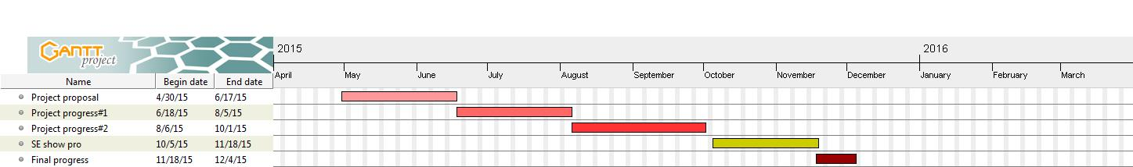

Figure 2.2: Promotion Provider Schedule and Milestone

* Project Proposal Presentation
* Progress Report I
* Progress Report II
* Final Project Presentation.

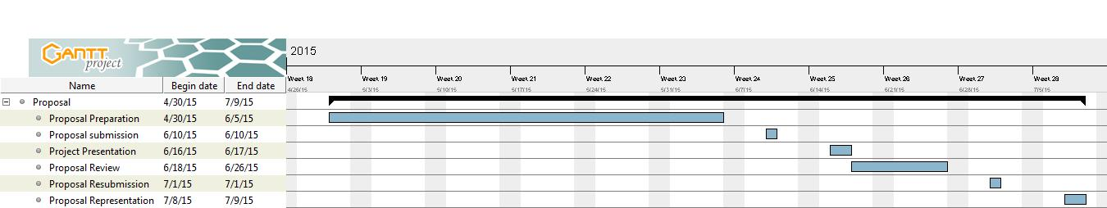

Figure 2.3: Proposal Milestone

* + - * Proposal Preparation
      * Proposal Submission
      * Proposal Presentation
      * Proposal Reviewing
      * Proposal Resubmission
      * Proposal Representation

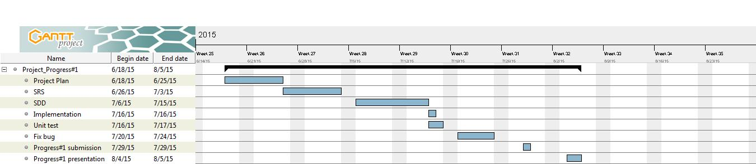

Figure 2.4: Progress #1 Milestone

* + - * Feature #1 Managing shop owner: System provide managing function(add, update, delete)
      * Feature #2 Managing promotion: System provide managing function(add and delete)
      * Feature #3 Changing password: All user type can change their password
      * Feature #4 Log in: Admin role and user role can log in to system
      * Feature #5 Log out: Admin role and user role can log out from system.
      * Project Plan
      * Software Requirement Specification for Progress I
      * Software Design Document for Progress I
      * Test Plan for Progress I
      * Feature Implementation
      * Unit Test for Progress I
      * Fix bugs
      * Progress Report I Submission
      * 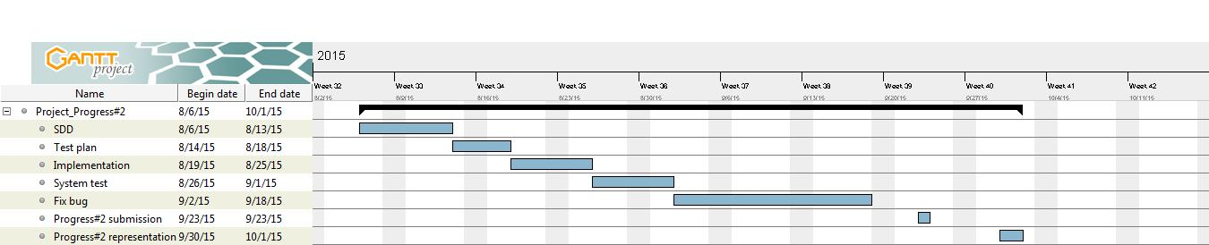Progress Report I Presentation

Figure 2.5: Progress #2 Milestone

* + - * Feature #6 Searching: System provide searching function for admin to search for shop owner account by id, or email, or shop name. Also searching function for admin to search for promotions by id, or shop name, or promotion name.
      * Feature #7 Displaying shop and information: System provide shop and its information which are name, address, email, open and close time, images and description
      * Feature #8 Displaying promotion and information: System provide promotion and its information which are name, start date, end date, description and images.
      * Feature #9 Requesting register. Guest can sent register request to admin to become a member.
      * Feature #10 Managing register request: Admin manage register request from guest (approve, reject)
      * Feature #11 Submitting redeem code: Shop owner submit redeem code which is from mobile user to let mobile user get discount
      * Software Requirement Specification for Progress II
      * Software Design Document for Progress II
      * Software Test Plan for Progress II
      * Feature Implementation
      * Test plan for Progress II
      * Unit test for Progress II
      * System Test
      * Fix Bugs
      * Progress Report II Submission
      * 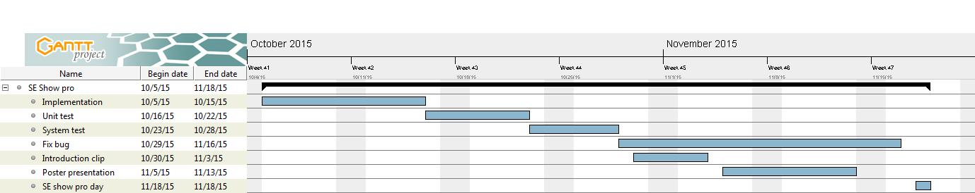Progress Roport II Presentation

Figure 2.6: SE Show Pro Milestone

* + - * Feature# 12 Displaying nearby promotion: Mobile user can view promotion and place in range
      * Feature# 13 Navigating to destination: System navigate mobile user from user’s current location to the destination place
      * Feature# 14 Searching: User search for promotions by name and search for shop by name
      * Feature# 15 Collecting point: Mobile user retrieve point by staying in setting range from shop
      * Feature# 16 Redeem point: Mobile user redeem their point from remaining point to get privilege
      * Feature# 17 Displaying remaining point: Mobile user can view their remaining point in system
      * Software Requirement Specification for Progress III
      * Software Design Document for Progress III
      * Software Test Plan for Progress III
      * Feature Implementation
      * Test plan for Progress III
      * Unit test for Progress III
      * System test
      * Fix bugs
      * 30 seconds Introduction Clips
      * Poster A1 For Presentation
      * SE Show Pro

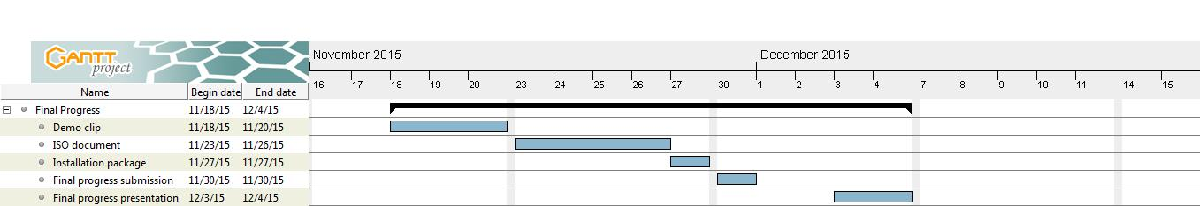

Figure 2.7: Final Progress Milestone

* + - * 5 minutes Demo Program Clip
      * The Full ISO 29110 Document
      * Installation Package
      * Final Report Submission
      * Final Report Presentation

# Chapter 6 | Software Configuration Management

Software Configuration Management is a set of activities designed to control change by identifying the work products that are likely to change, establishing relationships among them, defining mechanisms for managing different versions of these work products, controlling the changes imposed, and auditing and reporting on the changes made. In other words, SCM is a methodology to control and manage a software development project.

## 6.1 Filename Format

We control all document files in our project by use like:

**[Project Name]_[File Name]_[Version]. [File type]**

**Project Name**: This part will be full-name of project (Promotion Provider)

**File Name**: This part will depend on substance of that file:

* + Proposal
  + Project Plan & Quality Plan
  + SRS(Software Requirement Specification)
  + SDD(Software Design Document)
  + Code
  + Test Plan
  + Test Record
  + Traceability Record

**Version**: This part is version of file. Version number.

**File type**: This part is type of file.

## 6.2 Change Management

Change management manages all of the changes in the project during development process. All of the change requests will be record into the change request document.

We have the strategy for manage the changes by following these steps:

* 1. Analyzing the change.
  2. Setting the change request form.
  3. Approving the change request by project advisor.
  4. Change the project follow by approved change request.

## 6.3 Software Configuration Item Table

| **No.** | **Item** | **File name** | **File Type** | **Owner** | **Path** | **Baseline version** |
| --- | --- | --- | --- | --- | --- | --- |
| 1 | Project Proposal | Promotion provider_ProjectProposal_1.0 | .docx | Tanawat, Nattakit | www.dropbox.com/Promotion Provider 2015/Proposal/Promotion provider_1.0 | 1.0 |
| 2 | Project Management Plan | Promotion provider_ProjectPlan1 | .docx | Tanawat, Nattakit | www.dropbox.com/Promotion Provider 2015/Project Plan/Promotion provider_ProjectPlan_1.0 | 1.0, 2.0, 3.0 |
| 3 | Software Requirement Specification | Promotion provider_SRS_1.0 | .docx | Tanawat, Nattakit | www.dropbox.com/Promotion Provider 2015/Software Requirement/Promotion provider_SRS_1.0 | 1.0, 2.0, 3.0 |
| 4 | Software Design Document | Promotion provider_SDD_1.0 | .docx | Tanawat, Nattakit | www.dropbox.com/Promotion Provider 2015/Software Design/Promotion provider_SDD_1.0 | 1.0, 2.0, 3.0 |
| 5 | Test Plan | Promotion provider_TestPlan_1.0 | .docx | Tanawat, Nattakit | www.dropbox.com/Promotion Provider 2015/Test Plan/Promotion provider_TestPlan_1.0 | 1.0, 2.0, 3.0 |
| 6 | Test Record | Promotion provider_TestRecord_1.0 | .docx | Tanawat, Nattakit | www.dropbox.com/Promotion Provider 2015/Test Record/Promotion provider_TestRecord_1.0 | 1.0,2.0,3.0 |
| 7 | Traceability Record | Promotion provider_TraceRec_1.0 | .docx | Tanawat, Nattakit | www.dropbox.com/Promotion Provider 2015/Traceability Record/Promotion provider_TraceRec_1.0 | 1.0, 2.0, 3.0 |

Table 2.9: Software Configuration Item

# Chapter 7 | Repository

Figure 2.8: Repository